Hosed!

What Happens When You Surf Unprotected
Greetings beloved PCCupid Clients,
Let’s be clear, I did not write a word of this PCWorld article. PCWorld is a well-respected magazine and online source for viable computer information. I found its content most important in today’s home computing/internet environment. I simply wanted to pass this information along to you. You can find the full online article here at this web address: http://www.pcworld.com/article/206107/most_dangerous_places_on_the_web.html
- Your PCCupid, Keith Lawton

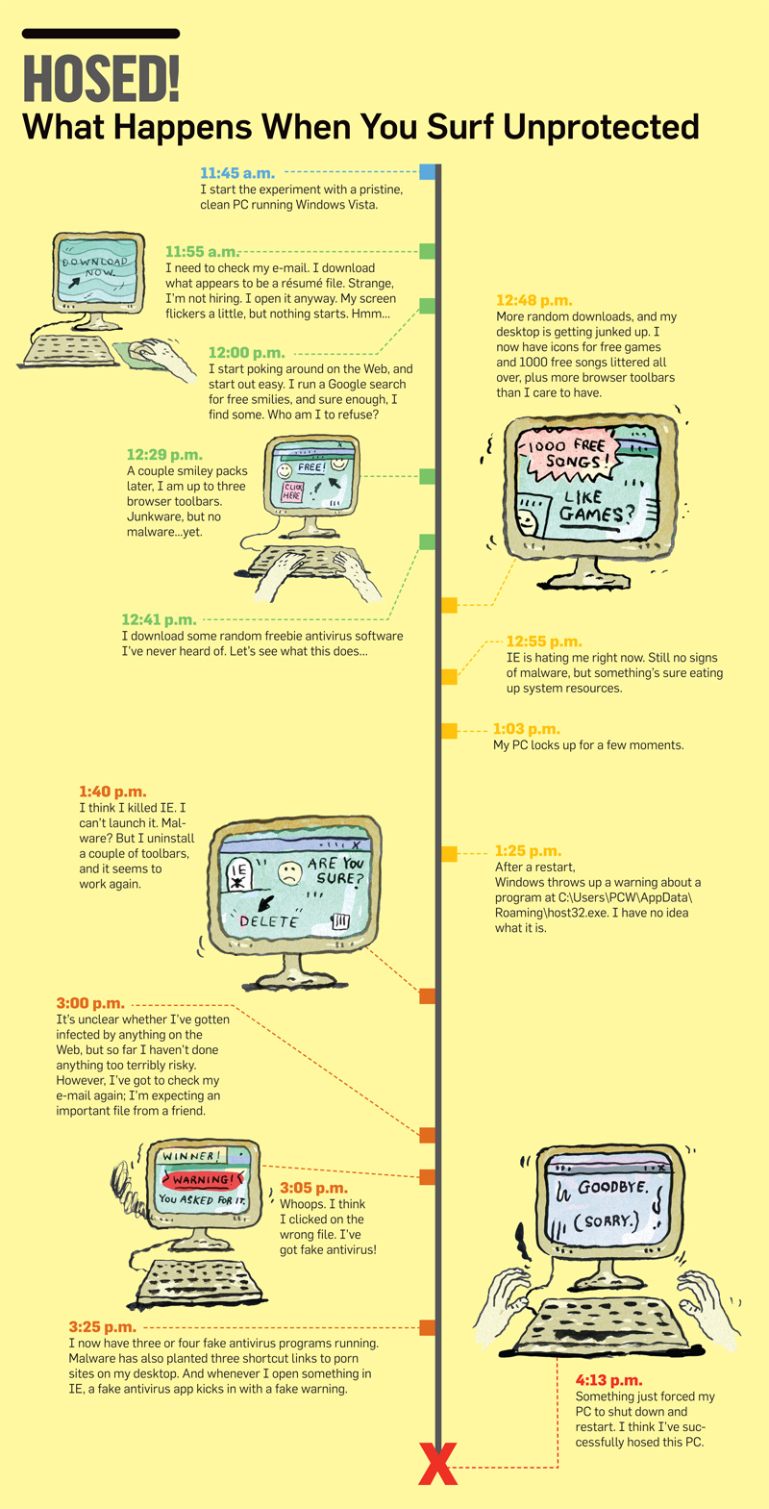
11:45 a.m. I start the experiment with a pristine, clean PC running Windows Vista.
11:55 a.m. I need to check my e-mail. I download what appears to be a résumé file. Strange, I'm not hiring. I open it anyway. My screen flickers a little, but nothing starts. Hmm...
12:00 p.m. I start poking around on the Web, and start out easy. I run a Google search for free smilies, and sure enough, I find some. Who am I to refuse?
12:29 p.m. A couple smiley packs later, I am up to three browser toolbars. Junkware, but no malware...yet.
12:41 p.m. I download some random freebie antivirus software I've never heard of. Let's see what this does...
12:48 p.m. More random downloads, and my desktop is getting junked up. I now have icons for free games and 1000 free songs littered all over, plus more browser toolbars than I care to have.
12:55 p.m. IE is hating me right now. Still no signs of malware, but something's sure eating up system resources.
1:03 p.m. My PC locks up for a few moments.
1:25 p.m. After a restart, Windows throws up a warning about a program at C:\Users\PCW\AppData\Roaming\host32.exe. I have no idea what it is.
1:40 p.m. I think I killed IE. I can't launch it. Malware? But I uninstall a couple of toolbars, and it seems to work again.
3:00 p.m. It's unclear whether I've gotten infected by anything on the Web, but so far I haven't done anything too terribly risky. However, I've got to check my e-mail again; I'm expecting an important file from a friend.
3:05 p.m. Whoops. I think I clicked on the wrong file. I've got fake antivirus!
3:25 p.m. I now have three or four fake antivirus programs running. Malware has also planted three shortcut links to porn sites on my desktop. And whenever I open something in IE, a fake antivirus app kicks in with a fake warning.
4:13 p.m. Something just forced my PC to shut down and restart. I think I've successfully hosed this computer.

